Computer graphics: Computer graphics is the art or science of producing graphical images with the aid of computer. (IEEE).

Image processing, computer vision, computer graphics:

* Different sources, processing methods, and usages: 
* Different input & output:

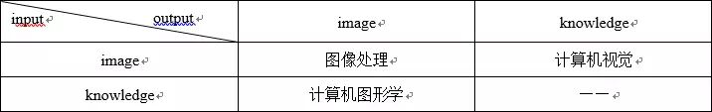

* Different usages:

Computer Graphics: computer animation, games, animation movies, AR / VR, (output is an image or a video, only create input X when needed).

Computer Vision: understand image, “ML”, (output is a probability, and needs lots of input data X).

Computer Graphics include:



* Math: vector, 2D <-> 3D
* Modeling: model object (build objects in a computer), complex calculations (for edges, curve, etc.)
* Rendering: draw textures, rays, particles, details, etc. (lots of calculations here)
* Interaction: AR / VR, e.g.: the “Gourand interpolation model” (draws its internal points by linear interpolation of the polygon vertex colors) and the “Phong interpolation model” (interpolating the normal direction of the polygon vertices to produce the normal direction of the middle points) are all geometric interpolation problems.

Modeling:

Three main categories



Rendering:

When outputting models of objects into videos, images, or tapes. “Models” are strictly constructed using algorithms, functions, and programming languages; rendering translates these “rules” into videos or pictures.

* Ray tracing: tracing light on every pixel of the image, so the image looks close to real-life image. Commercial movies trace more than 2000 lights on each pixel. It requires massive computing power, so computer games can use ray tracing (not now, now AAA games support tracing few lights).
* Lighting: simulates light in radiation, shades, etc.